# How to install Ubunti Linux on Lenovo T480

## Step1 - Partition your hard drive for DUAL Boot Installation.

Go to:

1. Disk Management > Right Click on “Windows (C: )” drive

1. Click on Shrink Volume

1. Enter the amount of space to shrink. Normally I would Split HD 50/50.
2. Click on Shrink
3. Once shrunk, you will see another partition for Hard drive

## Step2 - Need to disable to BitLocker first on Windows

Go to:

1. Manage BitLocker
2. “Click on “Turn Off BitLocker”

1. If Not Turned on yet, Turn it ON then Turn It OFF Again. Trust me
2. Once you Turn off bitlocker, Windows will Decrypt harddrive. This part will take some time.
   1. Make sure to refresh page to check if done already
   2. Once done, move to next step

## Step3 - Download Ubuntu

## Step4 - Download BalenaEtcher

1. Create a bootable USB drive using BalenaEtcher

## Step5 - BIOS Setup and Pre-Installation Steps

The first step before installing Linux is to make sure the system BIOS is setup correctly.

• Boot into BIOS by pressing the function “F1” key at the Lenovo splash screen.

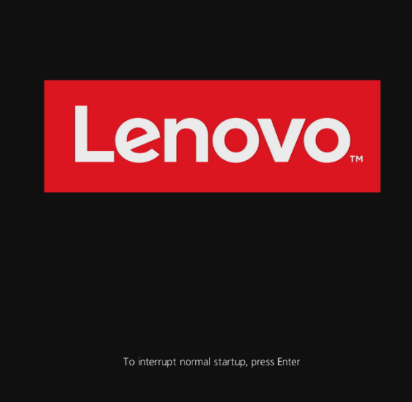

• Tab over to the “Restart” menu tab and set “OS Optimized Defaults” to “Disabled”.

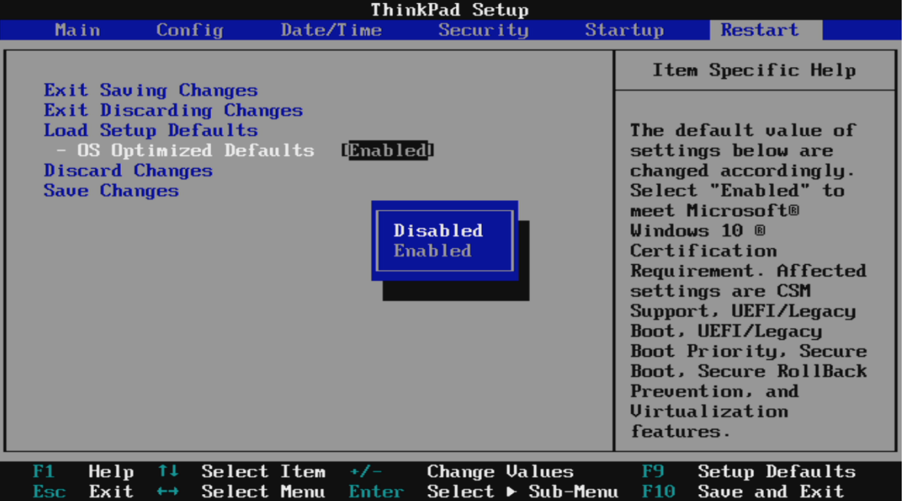

* Switching the “OS Optimized Defaults” settings may give a warning message. Select “Yes” to continue to disable OS Optimized Defaults.

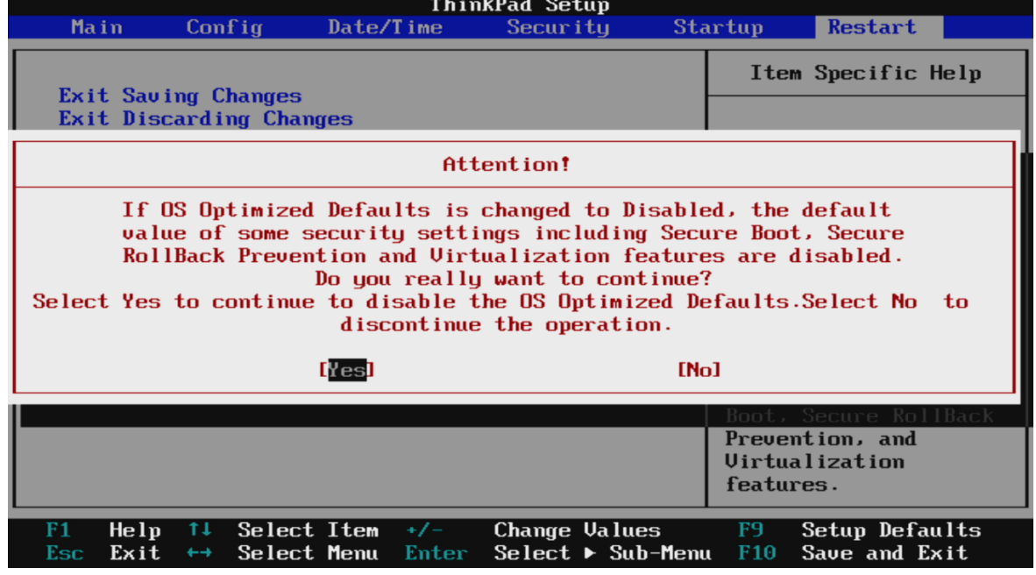

• Tab over to the “Startup” menu tab.

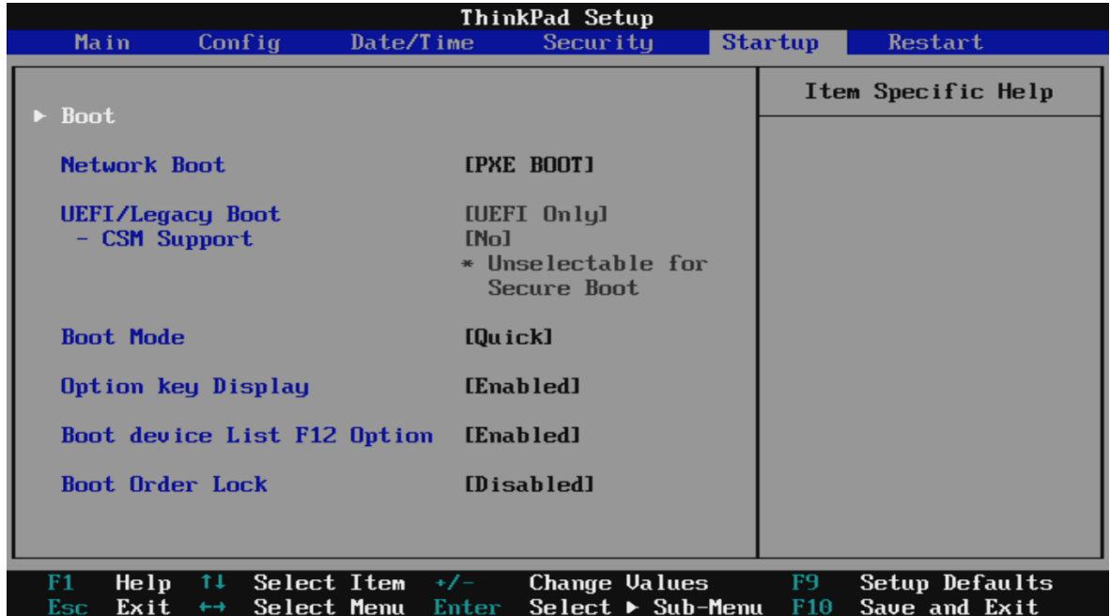

* Pressing F9 function key will allow Legacy and UEFI bootable devices by setting “UEFI/Legacy Boot” to “Both”; otherwise, it will be an unchangeable setting to UEFI only.

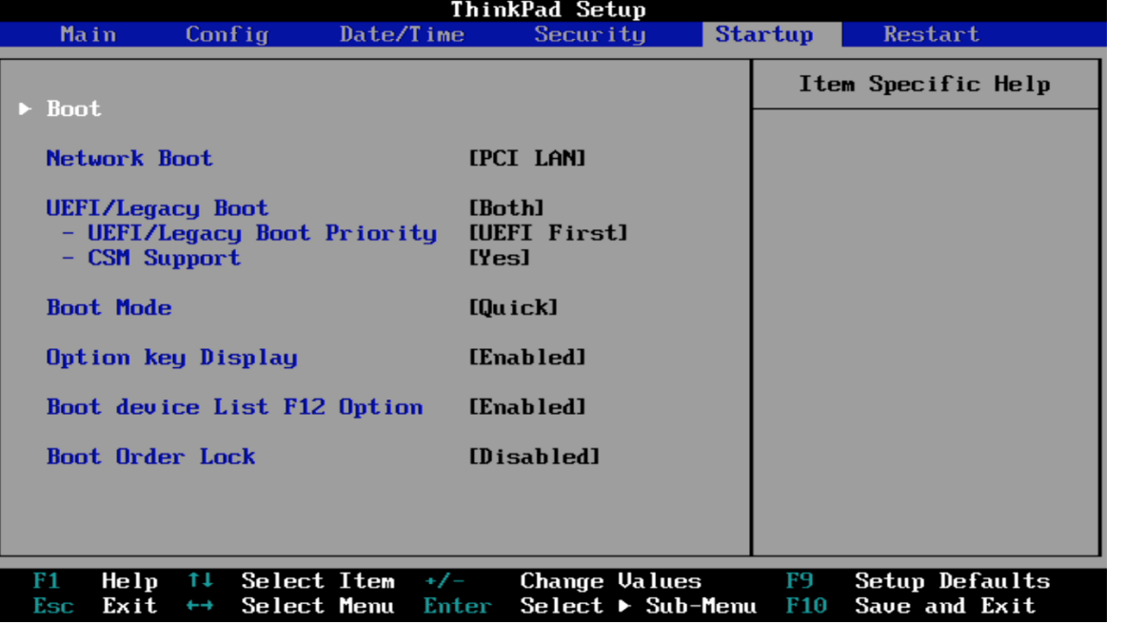

Only for P53s- Tab over to the “Security” menu tab, press “Secure Boot”. If Secure Boot is Enabled by default, then “Disable” it.

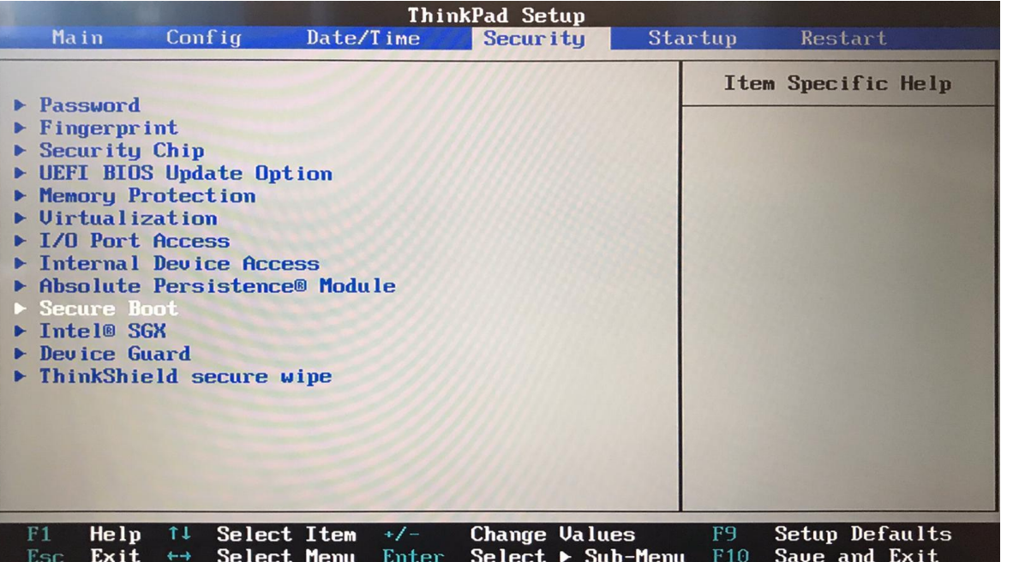

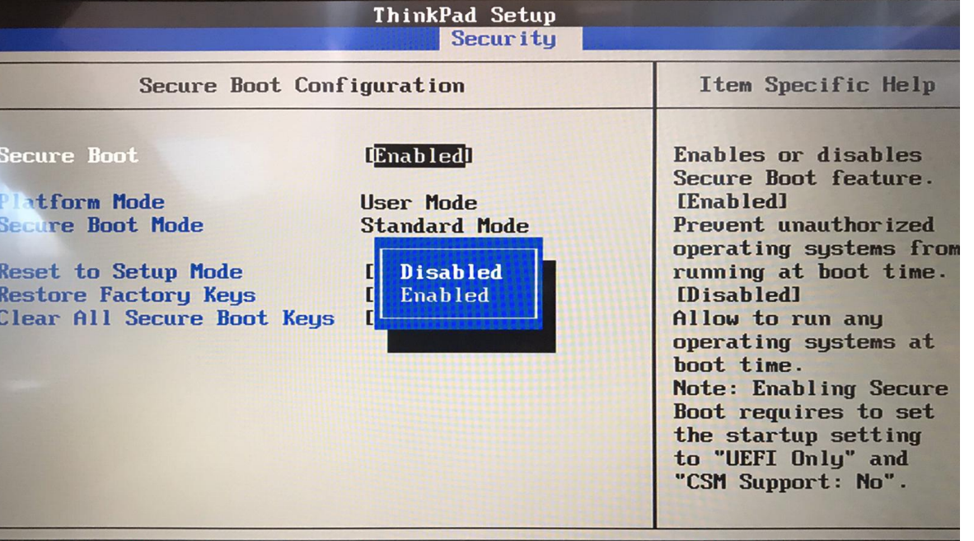

• Press function “F10” key to save and exit BIOS setup.

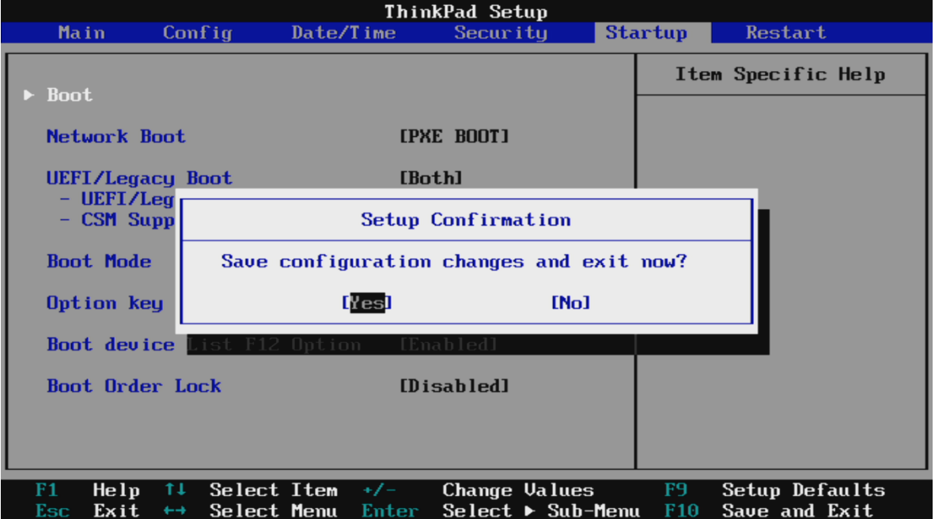

## Step6 - Booting Linux

• Insert the Ubuntu 18.04 LTS installation media (either through USB or CD/DVD). • Power on the system and press the “F12” function key whenever the following Lenovo splash screen appears.

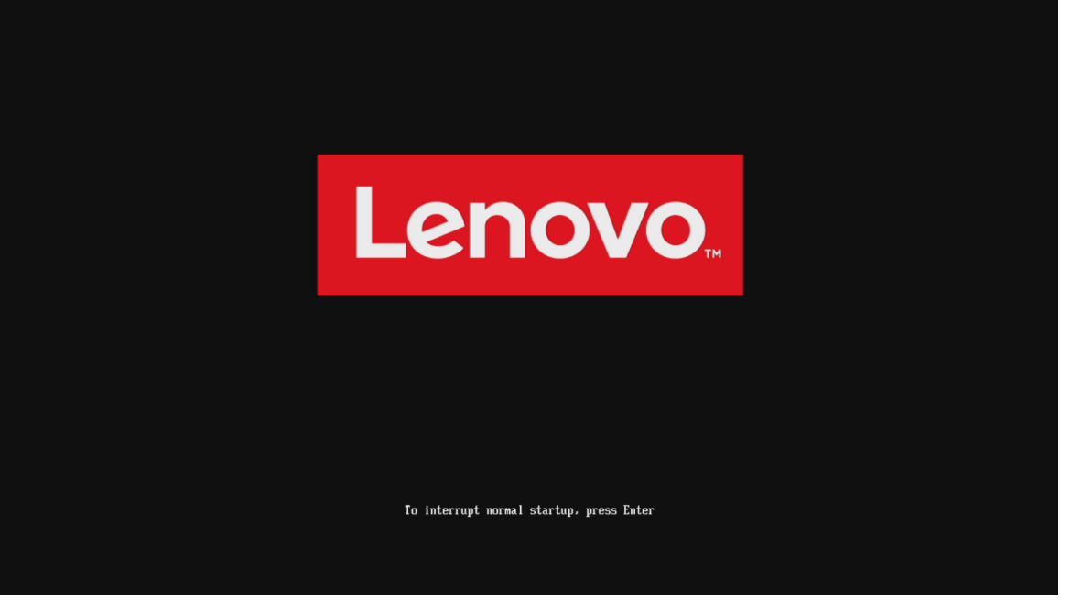

• Select the Linux bootable installation media from the “F12” boot menu list.

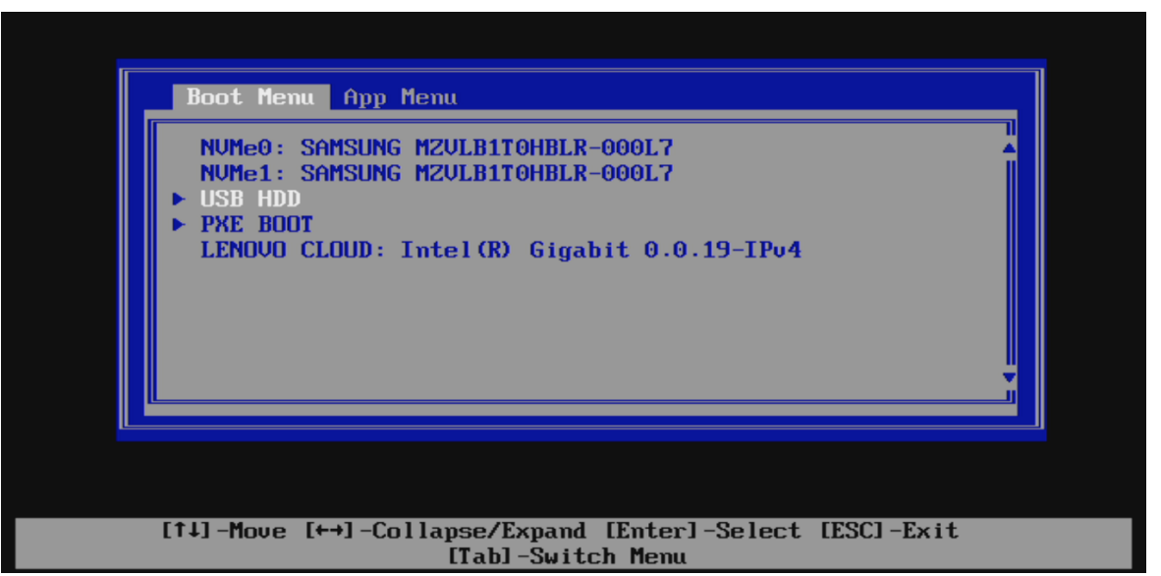

• Highlight “Install Ubuntu” from the GRUB boot menu and hit enter.

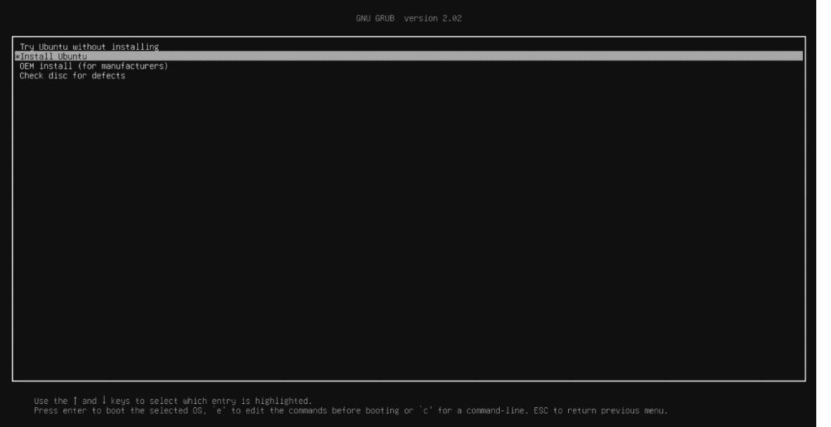

• The Ubuntu Linux Welcome Screen should appear. Select the appropriate language and “Continue”.

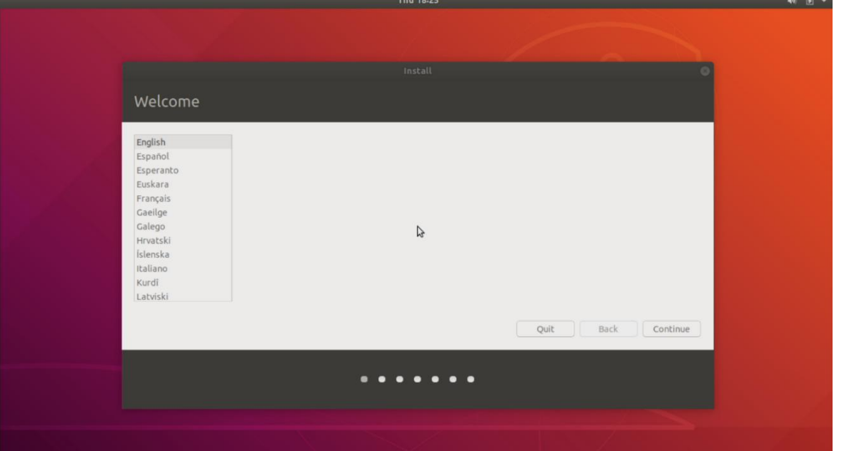

* Choose Keyboard Layout
* Select “Normal Installation” and “Continue”.

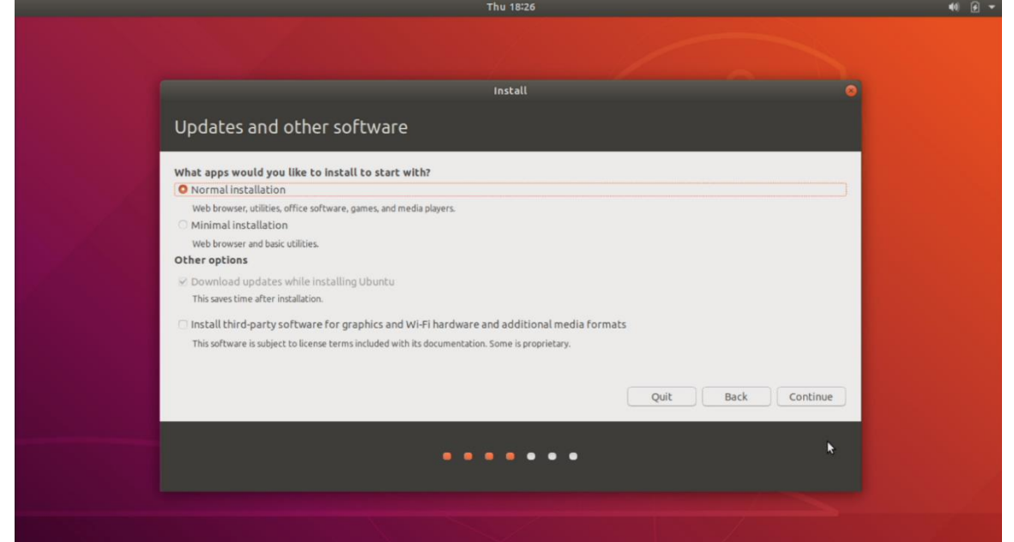

HOLD THE FUCK UP HERE PLEZZ …. You will need to choose the correct partition first

* Choose Installation Type:
  + You can “Erase Disk and install Ubuntu” – This will wipe HD and just use Ubuntu
  + Install Ubunti alongside Windows Boot Manager – This will allow Dual Boot ☺
  + Something Else
* Choose Some thing Else ….WHY ? Because you need to use the “Free partiion drive” you created for Linux. Remember we split the drive 50/50.

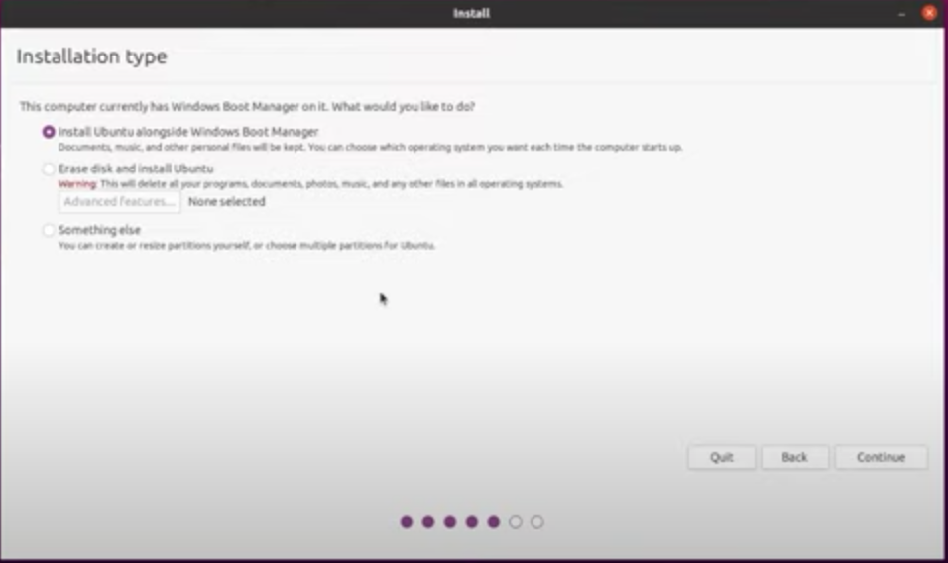

* Select continue
* Choose appropriate Geographical location
* Fill out text boxes

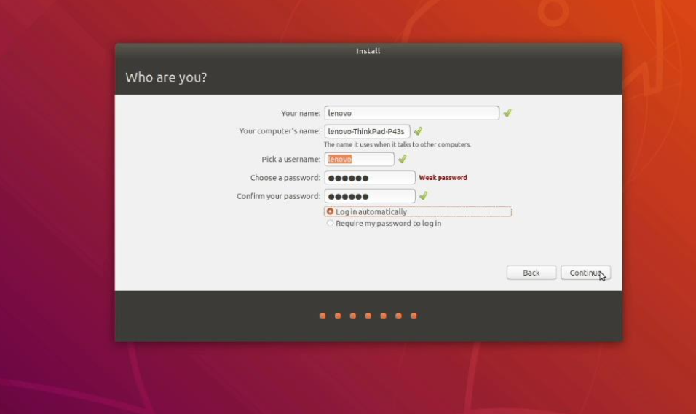

* Press Continue
* Once installation compeltes, click on Restart Now
* Remove installation USB drive and press enter

## Step8 - How To Boot Windows vs Ubuntu

1. When you power on, you will see the GRUB loader
   1. Choosing “*Ubuntu” will go to Ubuntu
   2. Choosing “Windows Boot Loader” will load Windows =)